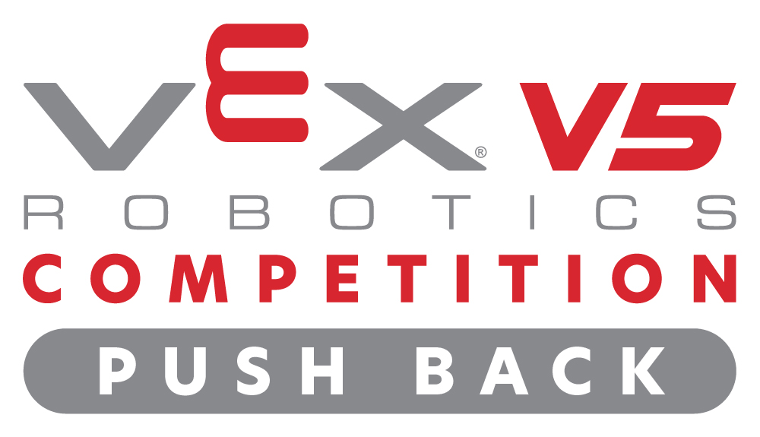
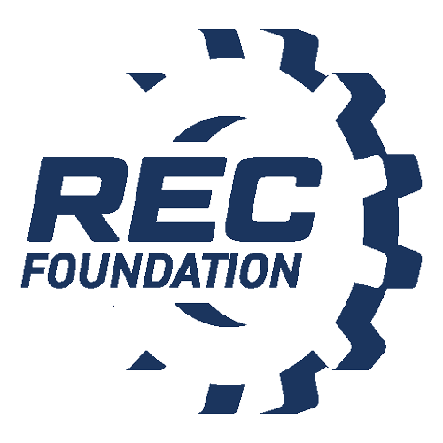
Media Contact
NAME:
PHONE:
EMAIL:
YOUNG INVENTORS GEAR UP FOR LOCAL VEX IQ ROBOTICS COMPETITION IN [INSERT CITY LOCATION]
Students Showcase STEM Skills with Custom-Built Robots at the [insert event name]
CITY, State – Month Day, Year – More than [insert number of participants] VEX V5 Robotics Competition students and mentors from around [insert team home towns] will unite at the [insert venue location] on [insert event date] for the VEX V5 Robotics Competition Push Back tournament, presented by the Robotics Education & Competition Foundation. The action-packed event will feature more than [insert number of teams] teams who will collaborate with other schools in a series of back-to-back robot challenges, made possible by the following sponsors: [insert sponsors]. Participants strive to succeed by strategically executing the game VEX V5 Robotics Competition Push Back, with robots they designed, built, and programmed using VEX V5.
VEX V5 Robotics Competition Push Back is one in a series of events taking place throughout the year. VEX Competitions represent the world’s largest and fastest-growing competitive robotics programs for elementary schools, middle schools, high schools, and colleges. There are more than 55,000 VEX teams from 125 countries that participate in over 3,613 events worldwide. The competition season culminates each spring with the VEX Robotics World Championship, a highly anticipated event that unites top qualifying teams from local, state, regional, and international VEX V5 Robotics Competition events who strive to secure the title of World Champions.
“Watching students experience the joy of bringing a robot from simple design renderings to the competition field is quite an amazing feat. To do so in such a short period, with the ability to meet up at a VEX V5 Robotics Competition event to compete with your peers and learn from each other is truly inspiring. This event will prepare students with the skills they need to become tomorrow’s leading innovators,” said [insert spokesperson], [insert title] of [insert company/affiliation]. Note: Customize the quote as you’d like.
The VEX V5 Robotics Competition serves as a vehicle for students to develop critical life skills, such as teamwork, ingenuity, and project management. These skills are honed through building robots and collaborating with like-minded students from the community.
More information about the VEX V5 Robotics Competition is available at recf.org.

About the Robotics Education & Competition (REC) Foundation
The Robotics Education & Competition Foundation’s mission is to increase student interest and involvement in science, technology, engineering, and mathematics (STEM) by engaging students in hands-on, affordable, and sustainable robotics engineering programs.
# # #

